PERFORMANCE ANALYSIS NFL 2014

California State University, Los Angeles

Roshik Ganesan

Lakshmi Sundararajan

**DATA SET URL**

**NFL 2014**

[**http://www.scan-support.com/help/sample-data-sets**](%20http:/www.scan-support.com/help/sample-data-sets)

This dataset NFL 2014 comprises the details of each that had participated in NFL season 2014. Comprising 89 columns and 533 rows this dataset consists details about every match that was played in the season. The field include the details about the team names, the venue capacity, the type of turf that is used for the match, along with this data it has lots of information which allows us to do a an entire performance analysis. It details us on the winner of each match the passing attempts made and the corresponding successful passing that they have made. It also tells us the number of intercepts made by the team in each week and how successfully they have managed to convert it for their team. This data details us more on the methods in which the teams have achieved their points with this the preffered method in achieving points could be found. It also contains data on the points that the teams have scored every week based on which the teams performance over the week is analysed. This data provides us a lot of insight to be analyzed which helps in doing a details performance analysis.

**DATA CLEANING**

1. **Removal of NA values**

Script

> nfl <- read.csv('sports.csv',sep='|')

> View(nfl)

> nfl<-na.omit(nfl)

> View (nfl)

|  |  |
| --- | --- |
|  |  |

1. **No columns to split**

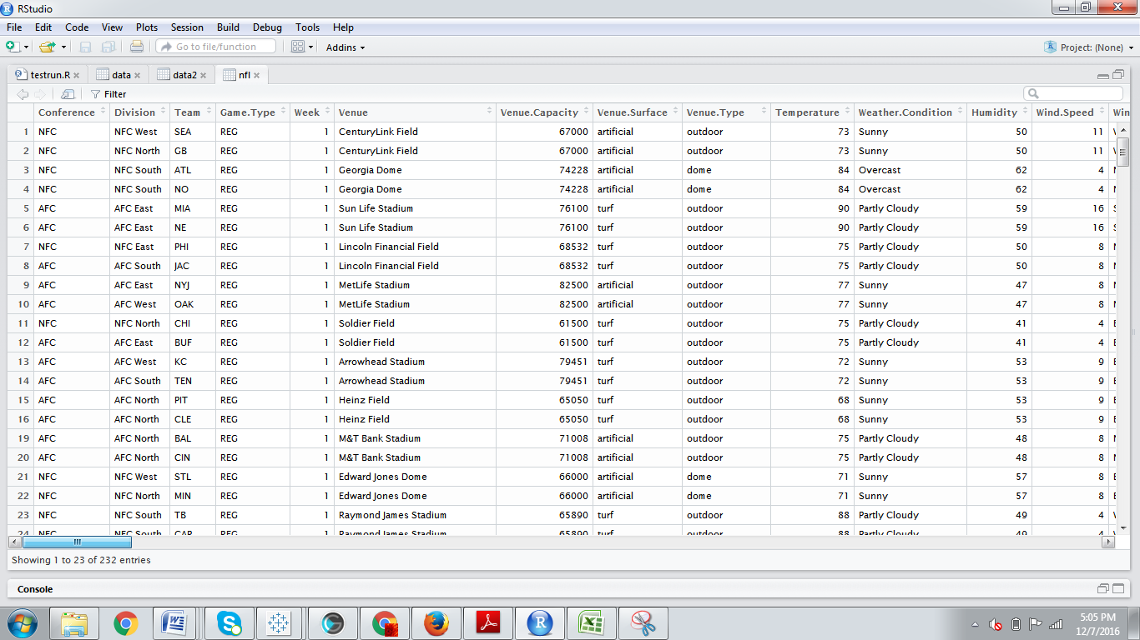

1. **Deleting Columns**

SCRIPT

>nfl$Redzone.TD<-NULL

> nfl$Redzone.Visits<-NULL

> nfl$Redzone.Efficiency<-NULL

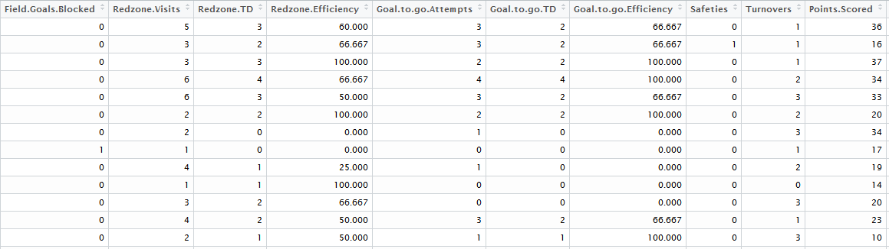

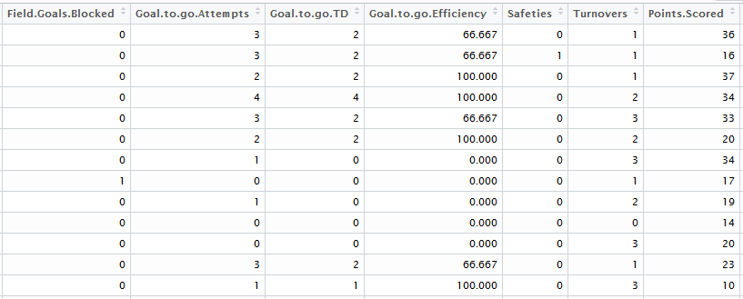

**ANALYSIS AND VISUALIZATION**

**Question 1: Win and Loss Comparison**

In this visualization, we have compared each team’s wins and losses of the season*.*  We can categorize the visualization based on Best, Average and Poor performers.Looking onto the bar chart that we have depicted below it is clear that IND( Indiana )has the highest wins of 14 matches and lost only 5 ,falling under the category of best performer .The average performers of the season based on this comparison are CAR(California), CLE and MIN(Minnepolis) where both win and loss are equal to 8 matches.Also, it is seen that the teams TB (Tampa Bay) and NYJ(New Jersey) has the least number of wins which is only 2 and 4 respectively. Hence these two teams fall under Poor performers.

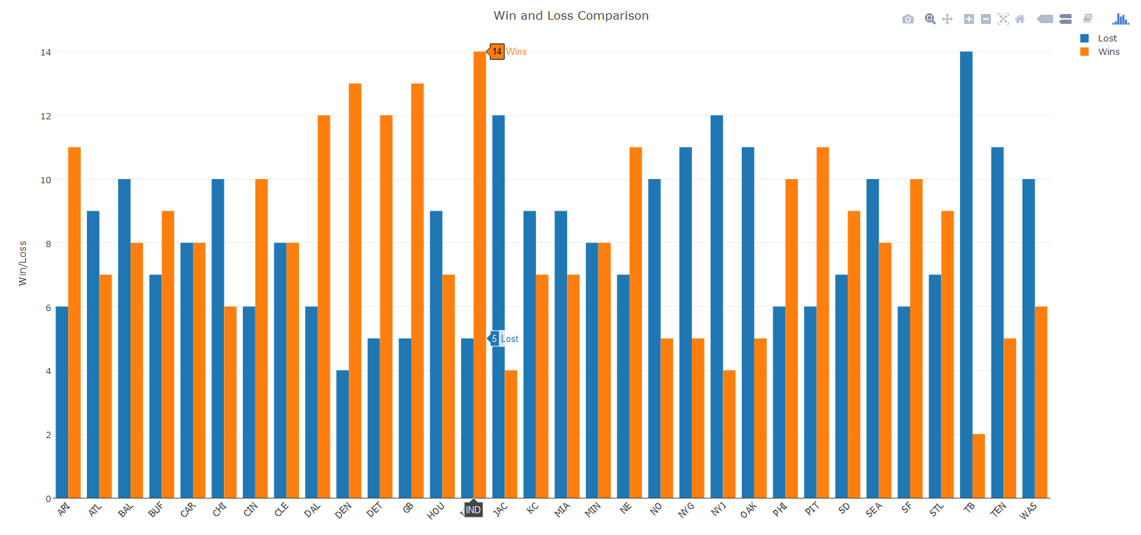

**Parameters Learnt In Class:**

**We have installed two packages Dplyr, Data.table. Using plot_ly we have done side by side bar. Colors' function is used.**

**Question 2: What are the Top 5 best intercepting teams ?**

In this visualization, we have considered the top 5 interceptions. The term interceptions mean tackling the opponents passes and gaining possession with the ball. As per the pie chart shown below, we can see that the team PHI(Philandalphia) has made the greatest interceptions of 21. Interesting point to note here is that the team TB(Tampa Bay) has the second highest interception percentage of 17.2 ,but has poor performance in the overall season.This indicates that TB though strong in interception couldn’t perform well because of the weak offense team. This states that interception is not an important parameter in achieving success in a season.

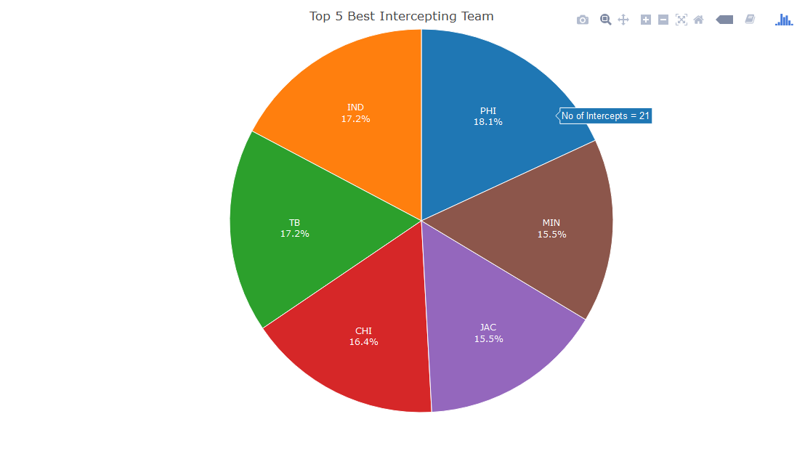

**Parameters Learnt In Class:**

**Using plot_ly we have made a pie chart. Colors' function is used.**

**Question 3: Which team has the best successful passing coversion ?**

In this visualization, we have done an analysis on the successful passing conversion percentage of the season.This is done by considering the total passing attempts out of which successful passing completion is done. These values are passed into the function which gives the result of success conversion percentage that is ordered in descending. It can be seen that the team NO(New Orleans) has the highest passing conversion percentage. Even though the passing percentage is high their overall performance is not significant. Whereas Dallas has a passing percentage of 68.8% which bolsters their consistent performance in the season. The top 5 teams in the list except for Dallas are average performers in the season which states that the passing conversion parameter doesn’t have a big impact on the overall performance but still maintaining a good percentage with a decent offence would stand good chances of outperforming the opponents in the season.

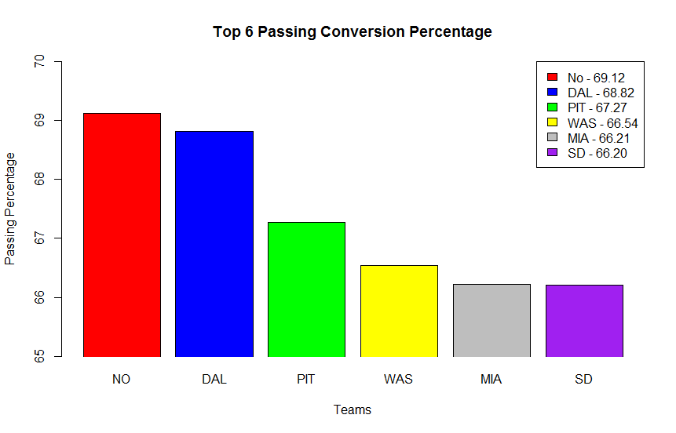

**Parameters Learnt In Class:**

**Color function, Standard Deviation and Plot_ly for bar chart is used. Then the legend function is also used for displaying legends**.

**Question 4: Weekly Analysis of the performance of the teams**

In this visualization, we do an analysis on the weekly performance of the teams. This analysis provides the user with the privilege to enter the team name at runtime and view only that particular team’s performance metrics. We have used a median function to represent the median score of the preffered team. We found that the performance of the team ARI (User Preffered) in the first half of the season is above the median scale whereas second half of the season is below the median scale. With this analysis the overall performance of the team can be improved by identifying the period where the team is outperformed, the underlying reason behind it and the means to achieve better performance during this period.

**Getting input from User Sample.**

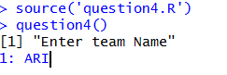

**Result Of Input**

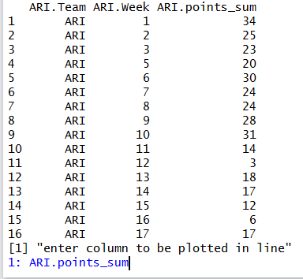

**Parameters Learnt In Class:**

**Median function and Plot_ly for Line Chart.**

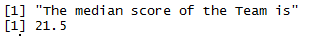

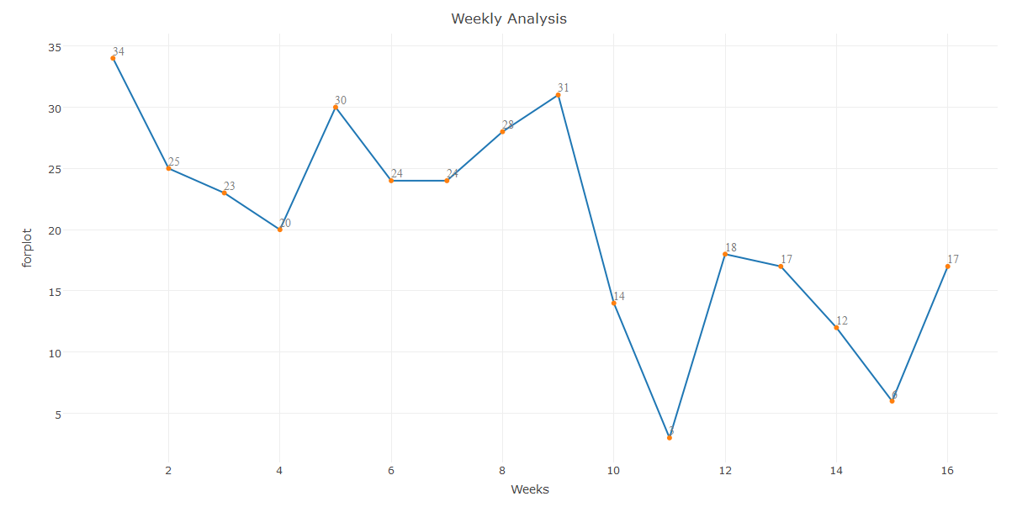

**Question 5: Finding the statistics behind achieving first down by the teams**

In this visualization, we have analyzed thestatistics behind achieving first down by the teams. The parameters taken into account are passing,rushing and penalty. Based on maximum total first down count it is being ordered and plotted in 3D scatter plot.Indiana which is the top team in the season have achieved the maximum first down by rushing and passing having least penalties. We can also note that the team NE (New England Patriots) has even numbers of rushing passing and penalty. Where as BAL has achieved maximum first downs still they weren’t successful in the season because they have achieved maximum first downs by penalties. So from this when compared to penalties the other two parameters such as rushing and passing should the best channel to achieve the first down. This would help the teams in achieving a competitive position in the season.

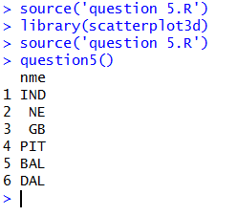

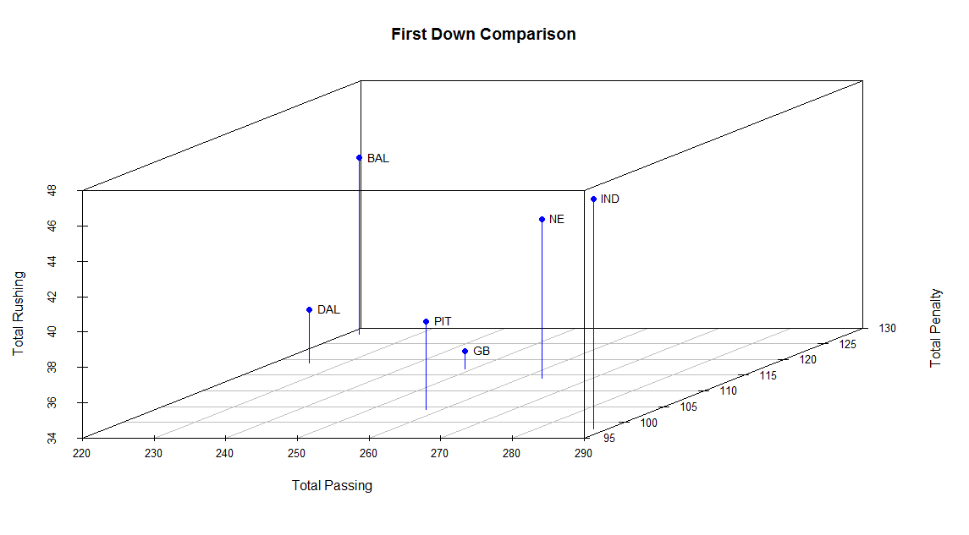**R CODE**

**Question 1 Script:**

install.packages('dplyr')

library(dplyr)

install.packages('data.table')

library(data.table)data <- read.csv('NFL.csv')

df1 <- data %>% dplyr::group_by(Team,X) %>% summarise ( count = n());

df1 <- data.frame(df1);

teamlist <- list(split(df1,df1$X));

loss_df <- data.frame(sapply(teamlist,'[','L'));

win_df <- data.frame(sapply(teamlist,'[','W'));

merge_df <- merge(x = loss_df ,y = win_df, by.x = "L.Team",by.y = "W.Team",all = TRUE );

merge_df <- data.frame(merge_df);

rowname <- merge_df$L.Team

plot_df <- data.frame(merge_df$L.count,merge_df$W.count,merge_df$L.Team);

print(plot_df);

Teamname <- merge_df$L.Team;

p <- plot_ly(plot_df,x = ~Teamname, y = ~merge_df.L.count, type = 'bar', name = 'Lost') %>% add_trace(y = ~merge_df.W.count, name = 'Wins') %>% layout(xaxis = list(title = '', tickangle = -45), yaxis = list(title = 'Win/Loss'), barmode = 'group', title = 'Win and Loss Comparison')

print(p)



**Question 2 Scrpit:**

data <- read.csv('NFL.csv')

df_1 <- data.frame(data);

df3<-group_by(df_1,Team) %>% summarise(total = sum(Interceptions));

total <- df3$total;

piechart <- df3[order(-total),];

df4 <- head(piechart);

total <- df4$total;

totals <- c('PHI','IND','TB','CHI','JAC','MIN')

pie_df <- data.frame(totals,total)

rownames(pie_df) <- pie_df$totals

piechart1 <- pie_df[,c('total','totals')]

p <- plot_ly(data, labels = ~totals, values = ~total, type = 'pie',

textposition = 'inside',

textinfo = 'label+percent',

insidetextfont = list(color = '#FFFFFF'),

hoverinfo = 'text',

text = ~paste('No of Intercepts =', total),

marker = list(colors = colors,

line = list(color = '#FFFFFF', width = 1)),

showlegend = FALSE) %>%

layout(title = 'Top 5 Best Intercepting Team',

xaxis = list(showgrid = FALSE, zeroline = FALSE, showticklabels = FALSE),

yaxis = list(showgrid = FALSE, zeroline = FALSE, showticklabels = FALSE))

print(p)



**Question 3 Script: (Standard Deviation)**

data <- read.csv('NFL.csv')

df_1 <- data.frame(data);

passing<-group_by(df_1,Team) %>% summarise(total_passing = sum(Passing.Plays));

total_passing <- passing$total_passing;

teams <- passing$Team;

passing_success <- group_by(df_1,Team) %>% summarise(success_pass = sum(Passing.Completions));

success_pass <- passing_success$success_pass;

sd_passing <- sd(success_pass)

print('The standard deviation of the Success Passing for the Season is')

print(sd_passing )

source('passing_function.R');

success <- passing_function(success_pass,total_passing);

linedf <- data.frame(teams, success);

ordered <- linedf[order(-success),];

top5 <- head(ordered);

newdf <- data.frame(top5);

nme <- newdf$teams;

lab <- newdf$success;

barplot(newdf$success,main = "Top 6 Passing Conversion Percentage",names = nme, col = c("red","blue","green","yellow","gray","purple"),ylim = c(65,70), xlab = "Teams",ylab = "Passing Percentage", xpd = FALSE);

legend("topright", legend = c("No - 69.12", "DAL - 68.82","PIT - 67.27", "WAS - 66.54","MIA - 66.21", "SD - 66.20"), fill = c("red","blue","green","yellow","gray","purple"))

**Function used – passing_function()**

passing_function <- function(x,y)

{

success_pass <- x;

total_passing <- y;

success_percentage <- ((success_pass/total_passing)*100);

return(success_percentage);

}

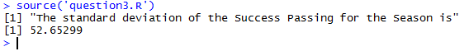





**Question 4 Script: ( Median)**

team_vect <- data %>% group_by(Team,Week) %>% summarise(points_sum = sum(Points.Scored));

team_df <- data.frame(team_vect);

teamlist <- list(split(team_df,team_df$Team));

print("Enter team Name");

teamnme <- scan("",what = "char");

team_df1 <- data.frame(sapply(teamlist, '[',teamnme));

print(team_df1);

print("Enter column to be plotted in line");

var <- scan("",what = "char");

forplot <- team_df1[,var];

Weeks <- c(1:16)

t <- list(family = "sans serif",size = 14,color = toRGB("grey50"))

plot_df <- data.frame(Weeks,forplot)

print('The median score of the Team is')

print(median(plot_df$forplot));

p <- plot_ly(plot_df, x = ~Weeks, y = ~forplot, type = 'scatter', mode = 'lines', text = ~forplot) %>% layout(title = "Weekly Analysis", showlegend = FALSE) %>% add_markers() %>% add_text(textfont = t, textposition = "top right")

print(p)



**Question 5 Script:**

install.packages("scatterplot3d")

library(scatterplot3d)

df_1 <- data.frame(data);

df7<-group_by(df_1,Team) %>% summarise(total_passing = sum(Passing.First.Downs),total_rushing = sum(Rushing.First.Downs),total_penality = sum(Penalty.First.Downs),total = sum(Total.First.Downs));

first_down_df <- data.frame(df7);

count <- table(df7$total_passing,df7$total_rushing);

name1 <- df7$Team;

total <- first_down_df$total;

ordered_value <- first_down_df[order(-total),];

top_ordered <- data.frame(head(ordered_value));

nme <- top_ordered$Team;

dfnme <- data.frame(nme);

print(dfnme);

sp3 <- scatterplot3d(top_ordered$total_passing,top_ordered$total_rushing,top_ordered$total_penality,color = "blue",type = 'h',pch = 19, main = "First Down Comparison",xlab = "Total Passing",ylab = "Total Penalty",zlab = "Total Rushing")

sp3.coords <- sp3$xyz.convert(top_ordered$total_passing,top_ordered$total_rushing,top_ordered$total_penality)

text(sp3.coords$x,sp3.coords$y,labels = dfnme$nme ,cex = .85,pos = 4)

